Learning Objectives in this Unit:
- Describe the kinetic molecular theory of gases and how it predicts the macroscopic behavior of gases
- Qualitatively predict the behavior of gases based on the simple gas laws, and perform quantitative calculations using the Ideal Gas Law
- Perform calculations for mixtures of gases using Dalton’s law and the concept of a mole fraction
Read more about this topic: Chapter 9
- Choose all of the statements that are true
  - The SI unit of pressure is pounds per square inch (psi)
  - Pressure is the force exerted on a given area
  - Gas pressure is the result of molecules colliding with surfaces
  - A barometer is used to measure the pressure of a gas trapped in a container
  - Mercury is often used in barometers because it is very dense

- Consider each of the manometers below; choose the correct statement
  - For the gas picture in the open ended manometer below…
    - The pressure of the gas is equal to the pressure of the atmosphere
    - The pressure of the gas is less than the pressure of the atmosphere
    - The pressure of the gas is greater than the pressure of the atmosphere
  - For the gas picture in the open ended manometer below…
    - The pressure of the gas is equal to the pressure of the atmosphere
    - The pressure of the gas is less than the pressure of the atmosphere
    - The pressure of the gas is greater than the pressure of the atmosphere
Image Credit: https://openstax.org/books/chemistry-2e/pages/9-1-gas-pressure
- Name each of the following laws and fill in the blank with “directly” or “inversely”
Match each of the simple gas laws to their name
[_____] Law– The pressure of a gas is [_____] proportional to temperature (assuming the amount and volume are held constant).
[_____] Law – The volume of a gas is [_____] proportional to temperature (assuming the amount and pressure are held constant).
[_____] Law – The volume of a gas is [_____] proportional to pressure (assuming the amount and temperature are held constant).
[_____] Law – The volume of a gas is [_____] proportional to the number of mols (assuming the pressure and temperature are held constant).

- Fill in the blanks
The ideal gas law is only reasonable for gases at relatively [_____] pressure and [_____] temperature.
- Indicate whether the following statement is true or false
The value of R used in calculations is chosen based on the units required by the problem.
- Match the variables in Dalton’s law to their definitions
P_{A} | the mole fraction of the gas
X_{A} | the partial pressure of the gas
P_{Total} | the total pressure of the gas

- Consider the following containers of gas:
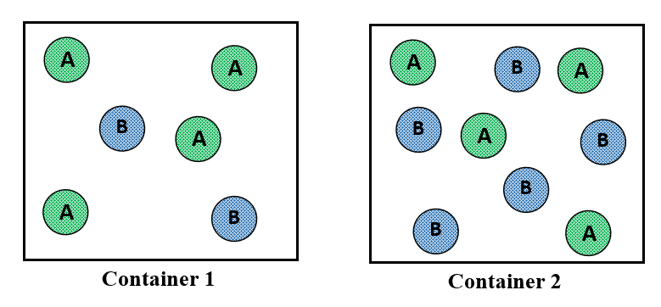
  - Assuming that Container 1 and Container 2 each have a total pressure of 1.0 atm. In which container is the partial pressure of B higher than the partial pressure of A?
  - Assuming that Container 1 and Container 2 each have a total pressure of 1.0 atm. In which container is the partial pressure of B lower than the partial pressure of A?
- Choose all of the statements which are postulates of kinetic molecular theory
  - Gas molecules are all noble gases
  - Gas molecules are in continuous motion, traveling in straight lines until collision
  - Gas molecules exert not attractive or repulsive forces on each other or the container
  - The average kinetic energy of the gas molecules is proportional to the kelvin temperature
  - Pressure results from the low density of gases

